**12.02 Assignment Instructions**

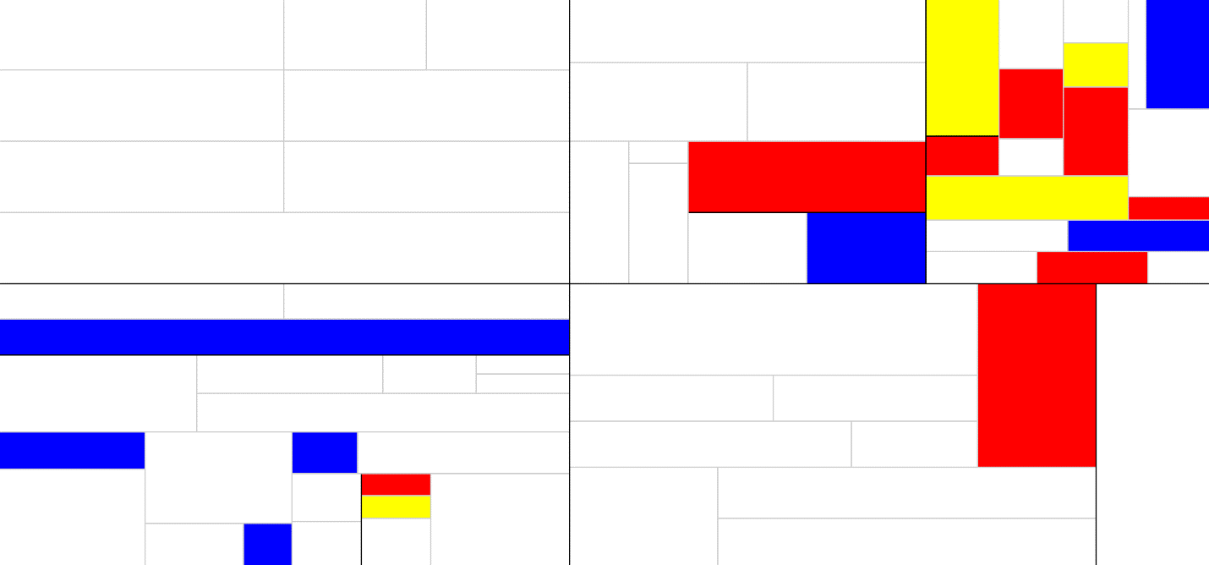**Instructions:** Create an image representative of the Neoplasticism style, using a recursive design algorithm.

***Sunset over Water – Jarod Peachey***

1. **Explain how you used the principle of recursion to create your image.**

In creating my artwork, I used the principle of recursion to help me. In order to create my masterpiece, I segmented the canvas into two sections, right down the middle. Then, I started segmenting the one on the right. Each time I created a new segment, I would finish that one, and then move back to creating more segments higher up in the tree. After I was done with the right side, I moved on to the left side and did the same thing.

1. **Briefly describe a plan for how you might write a program to produce Mondrian art.**

In order to write Mondrian Art generator program, I would generate variables using Math.random. These variables would represent the weight of color to white, as well as other things like vertical/horizontal splits. I would use equations to split each panel into more sections.

1. **Who should get the copyright credit for a piece of computer art: the CPU, the software, or the programmer? Explain your reasoning.**

I believe the programmer should get the credit. The programmer is the one that put in all the work, effort and time to create the generator.

1. **If a computer, with no human intervention, produced Mondrian art indistinguishable from an original masterpiece, would it be a sign of artificial intelligence?**

No. AI would be if the computer were able to create any piece of art based of commands from a person. Even if the computer had never seen or heard of that art technique.

1. **If a computer, with no human intervention, produced Mondrian art indistinguishable from an original masterpiece, would it diminish the accomplishments of a human?**

No. The time and effort put in by a human is what makes art so valuable. Take a painting, for example. If an artist creates a painting, there are often prints of it made. You can hardly tell the difference, but the prints sell for quite a bit less than the original. It’s because the original took time, effort and hard work.